PREPARATION AND MAINTANENCE OF ZOHO BOOKS

FOR EDU CONNECT LEARNING CENDER

1. INTRODUCTION :

1.1 overview :

* Learning Center means a facility in which a consistent group of students meets more often than once per week under the supervision of a Teacher or Mentor for a significant portion of a school day for the purpose of participating in an Online School.
* such as faculty development centers, teaching and learning centers, centers for teaching and learning, centers for teaching excellence, academic support centers, and others; a common abbreviation is TLC.
* **This means that learners are encouraged to participate in a series of tasks including speaking, listening, writing and collaboration with other students**.
* **Student - centered learning allows students to actively participate in their learning. In a student-centered classroom, the focus of activity is the student**.

**1.2 purpose:**

* edu connect is an innovative education-focused web application that is changing the way parents, students and educators discover, research and review schools and educational programs.
* **The activities are used to focus on a set of skills and deepen the students' knowledge and abilities in that area. Students can work alone, in pairs, or in small group .**
* provide students with opportunities to increase and enhance their academic skills and abilities through cultivating effective learning practices.
* **To organize workshops and seminars to facilitate capacity building and professional development of teachersTo provide assistance and support for promoting best practices in teaching learning environment through research and dissemination of already generated knowledge**.

**2.1 2 PROBLEM DEFINITION & DESING THINKING:**

**Empathy:**

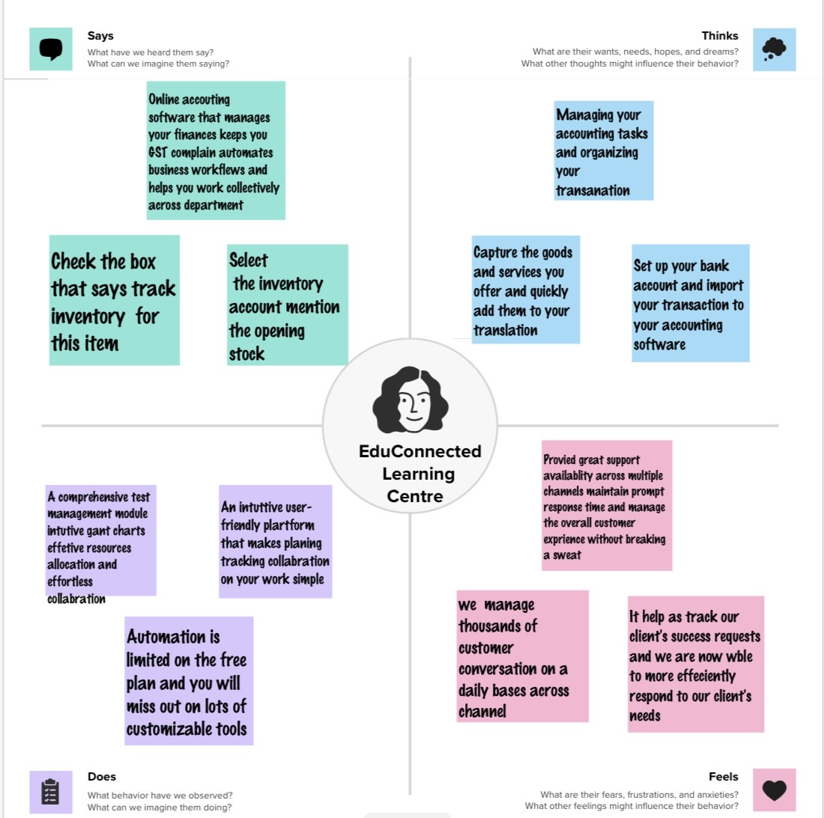

**2.2 Ideation & brainstroming map :**

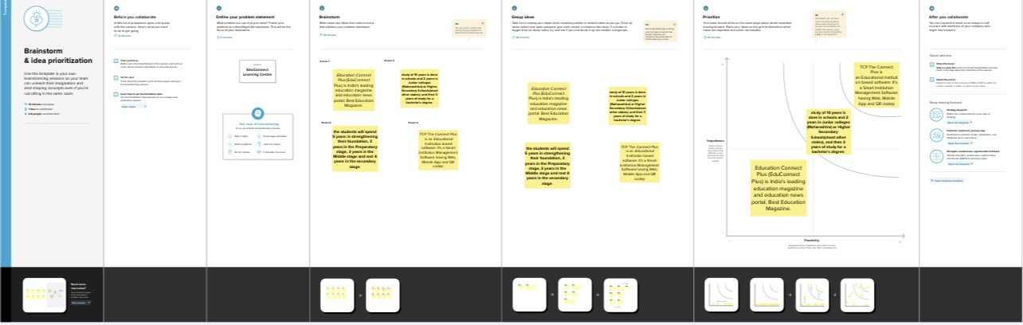

3 RESULT :

* Our platform provides a wide variety of courses, knowledgeable teachers, and interactive **learning** tools, encouraging people to develop their skills and meet
* For students with barriers, learning centers are designed to be aesthetically calming and non- judgemental. Instead of calling teachers by their last name–as in traditional classrooms
* –st udents call everyone by their first name.
* Education can used to improve the student language .

**OUTPUT OF PROFIT & LOSS**

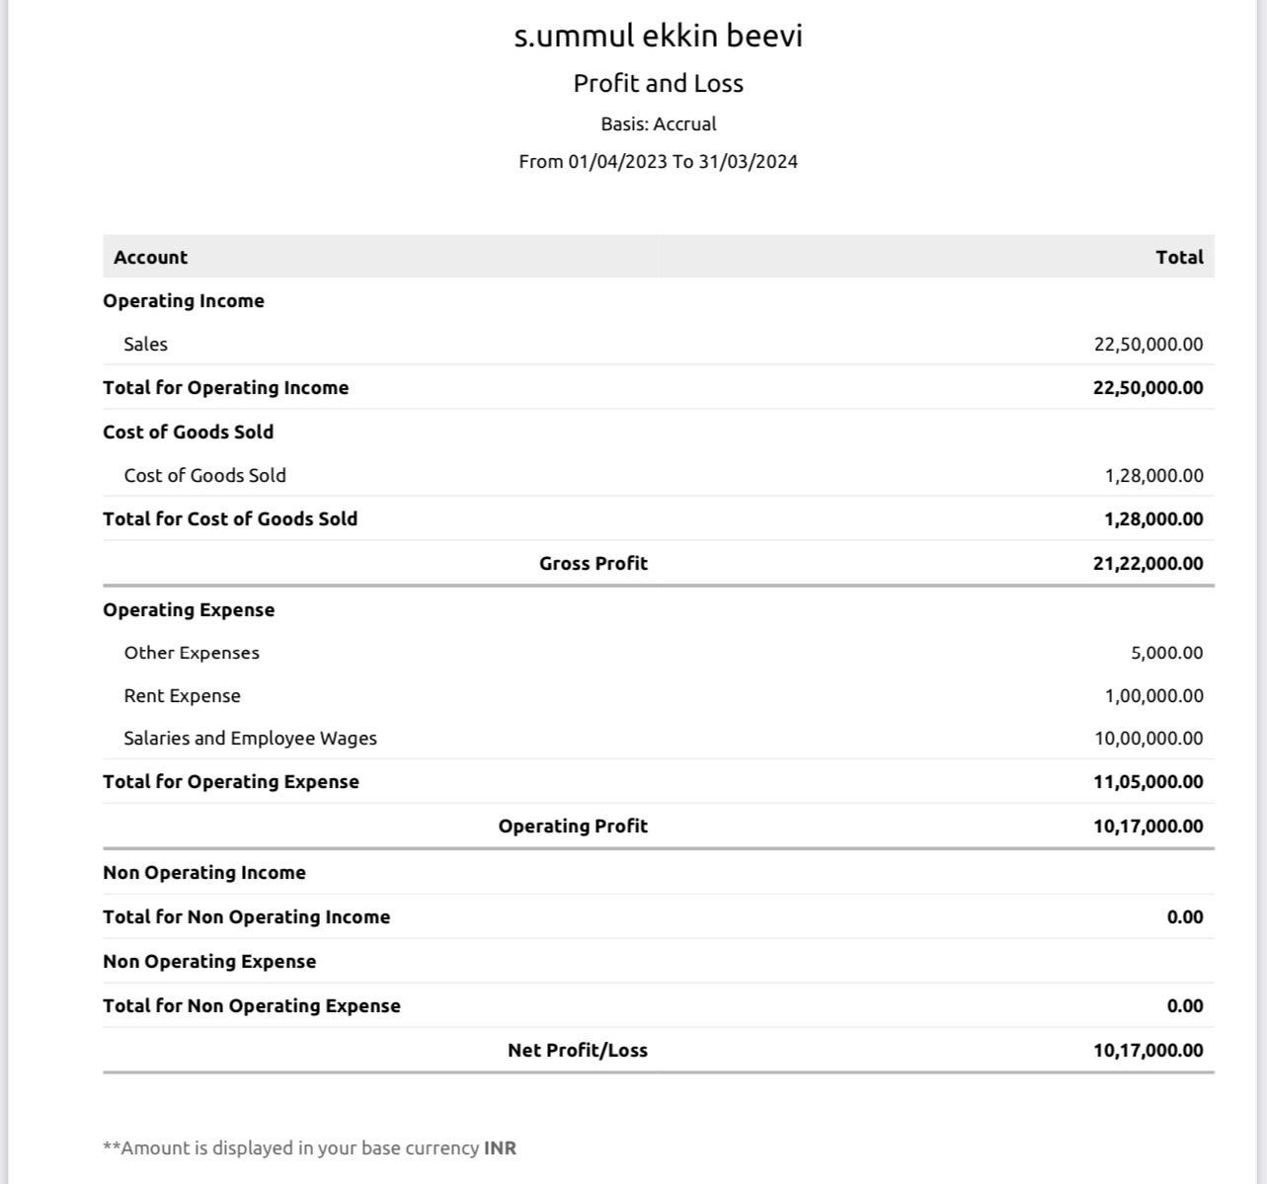

* BALANCE SHEET

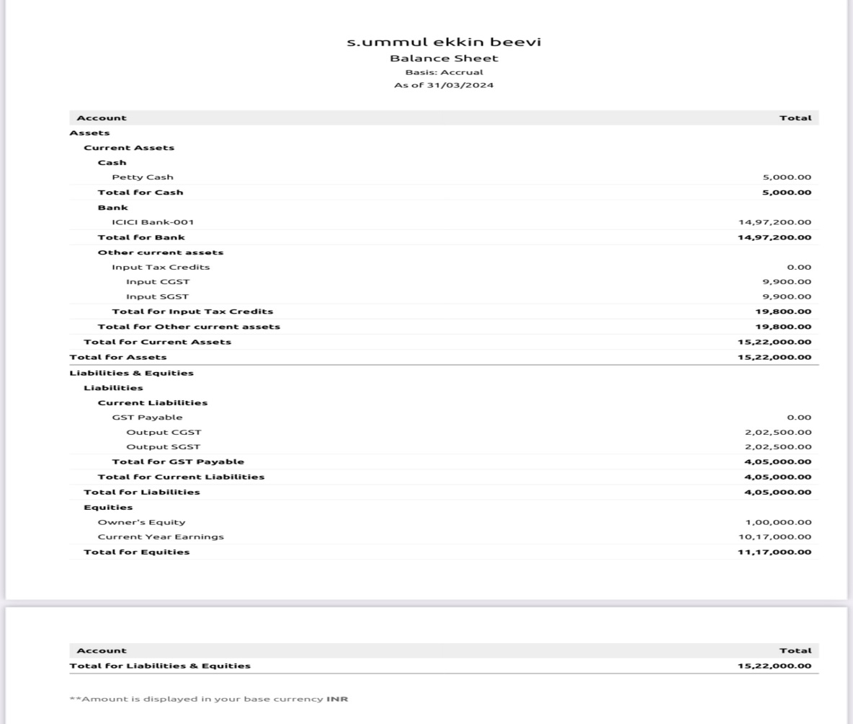

4 ADVANTAGES & DISADVANTAGES :

* Advantages :
* Allows slower students to spend more time practicing lessons from class while more advanced students deepen their understanding and ability to use the target skills or language
* Including greater accessibility regardless of location, resource scalability, improved academic results, self-paced learning, and cost-effectiveness..
* Connected learning is meant to create personalized learning pathways for students. This type of learning connects academics to personal interests, learners to mentors and educational goals to higher order learning skills.
* Disadvantage :
* One of the major disadvantages of online education can be the lack of physical interaction, which can make it more challenging for you to communicate with your fellow students and tutors.
* Planning to co-teach can be challenging. Unfortunately, my co-teaching situation was part-time. ...
* It can be difficult for teachers to get out of their comfort zone. ...
* If the chemistry isn't there, co-teaching is super difficult. ...
* It can be too easy for admin to see co-teaching as a flexible situation.

5 APPLICATION :

* Education is a content destination where teachers can search and assign Android apps, Chrome apps, YouTube Edu videos, and books to use with Android tablets and Chromebooks.
* This method of zoho books solution may applied to edu connected learning center .
* This may be suitable for education purpose .

**6 CONCULATION :**

* The zoho book for education connect leadning cender.
* The was very easy to apply translation on

Zoho books

* It was cearly understandable for learning project for

Edu connect learning center.

7 FUTURE SCOPE :

* In zoho book the perpration and maintainence of zoho books for edu connect learning center is very use full for future referance
* This maintanence of zoho books help to manage tranclations in future efficiently .